Control Center - End User Documentation

## 

## Overview

**General Information**

**Key Terms**

**Getting Access**

Requirements to access Control Center

Logging in to Control Center for the first time

Logging in to Control Center from Smartsheet

**Control Center**

**The Home Page**

Navigating to the Page

Page Contents

**New Project page**

Navigating to the Page

Page Contents

**The Project Update Page**

Navigating to the Page

Page Contents

**Provisioning a Project**

Project Kickoff (Intake)

Project Setup - 1. Project Type

Project Setup - 2. Templates

Project Setup - 3. Project Information

Project Setup - 4. Sharing

Project Provisioning

Project and Portfolio Reports and Dashboards

**Updating a Project**

Updating Project Templates

Updating Project Metadata

## “The Happy Path goes Here”

0.0 this goes here….

## General Information

### Key Terms

#### Control Center

Smartsheet Control Center enables business leaders to deliver work at scale by driving consistency in work execution, automating portfolio reporting and reducing operation risk through automation.

* 1. **End User**

An “End User” in this context is responsible for provisioning projects using Smartsheet Control Center. Typically this is a project manager, client onboarding manager, or a store construction manager. It is someone who is charged with creating and managing ongoing projects.

* 1. **Program Leads**

A “PMO” is responsible for the overall management of the portfolio of projects. This role is typically found in a PMO organization within the company or a similar type of function. Management activities include oversight of the portfolio reporting and dashboard function while also managing the creation and editing of project types. Additional functions include the ongoing change management associated with Control Center including global updates and project close-out.

#### Project Summary Data

In the context of Smartsheet Control Center, “metadata” essentially is a set of data that describes and gives information about project types (aka “tiles”). For example, ‘project manager’ is a data field or metadata that contains the values “Brendan Reed” which is the variable information assigned to an instance of the project type.

#### Project Blueprints

A Smartsheet Control Center Project Type represents a collection of sheets, reports, dashboards, and metadata that is configured for a specific business process. Examples of a business process include customer onboarding, store construction, IT projects, mergers & acquisitions, audits, etc. Each of these examples represents a given project type. Sometimes project types are referred to as “tiles”.

#### Project Artifacts

Control Center project artifacts consistent of specific sheets, reports, and dashboards that make up a project.

#### Workspaces

A workspace in the context of Control Center can either be the “Control Center” admin or project workspace. The admin workspace is where the **Project Blueprints** are managed along with the intake sheet, summary report and summary dashboards.

The project workspace contains the projects provisioned by Control Center. Each project is an individual folder with unique instances of the sheets, reports and dashboards along with the associate metadata based on the project Blueprint chosen when the project was provisioned.

* 1. **Project Reports**

Project reports are associated with the project instance. Project reports can aggregate information from multiple sheets in a given instance (e.g. budget, issue, and plan sheets) while applying filters to give various perspectives of project instance status. Examples of a project instance reports include project budget vs actual variance report and project status.

* 1. **Project Dashboards**

Similar in nature to project reports, project dashboards provide an a view of a project instance. A new store opening project instance, for example, would have a project dashboard scoped to that particular project.

* 1. **Blueprint Summary Sheets**

Control Center maintains a special sheet called the Blueprint Summary Sheet. This sheet pulls metadata from the individual sheets of each project into one single row using cell-links.

The result is a sheet where each row is a high-level summary of key metadata for each project. This dataset can be used to provide summary reports on a set of the projects in the portfolio. This dataset can also be aggregated and analyzed using Smartsheet formulas to generate portfolio level metrics and insights. The reports and metrics can in turn be presented in Portfolio Dashboards,

* 1. **Portfolio Dashboards**

Portfolio dashboards provide an aggregated view of key information about the portfolio of projects so stakeholders can quickly get an overview. Key information can include portfolio level metrics and insights, and summary reports of projects. The primary source of information is the Blueprint Summary Sheet but any information available in Smartsheet can be put on the Dashboard.

Another purpose of Dashboards is to provide navigation links to dive deeper into project details or provide links to commonly used objects, forms and web pages.

### Getting Access

#### Requirements to access Control Center

You must be a licensed Smartsheet user to be given access to Control Center. Access is typically managed via Smartsheet Groups that are permitted by the Program Lead.  
  
Once a project is provisioned from Control Center—that is, once you’ve started a project using Control Center—any Smartsheet collaborator can use that provisioned project as long as they’ve been given the required sharing permissions.  
  
For more information about Smartsheet permissions, please review the [Sharing Infographic](https://help.smartsheet.com/articles/2476646) or see the article on [Sharing Permission Levels](https://help.smartsheet.com/articles/520104).

#### Logging in to Control Center for the first time

1. Go to this link <<https://smartsheet.controlcenter.smartsheetapps.com>>
2. Click the **Log in with Smartsheet** button, and then click **Allow** when prompted to “Allow Access?”

***Tip****: Bookmark the Control Center URL <*[*https://smartsheet.controlcenter.smartsheetapps.com*](https://smartsheet.controlcenter.smartsheetapps.com)*> for quick access!*

#### Logging in to Control Center from Smartsheet

1. [Login to **Smartsheet**](https://app.smartsheet.com/b/home)
2. Click on your **User Profile** icon

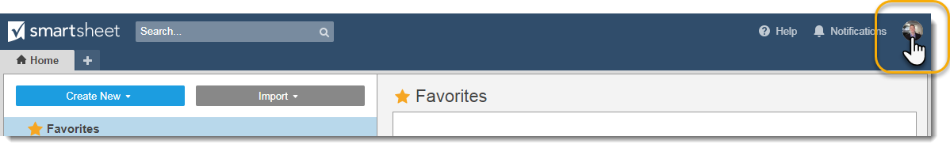

1. Click on **Apps & Integrations**

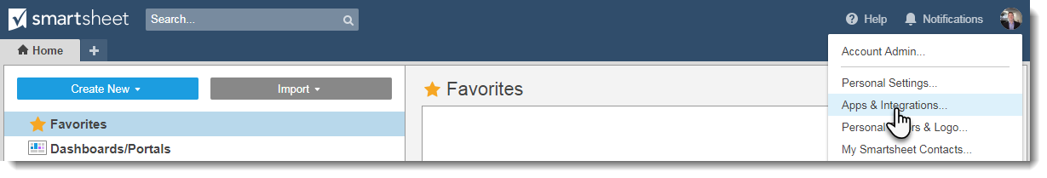

1. Select **Smartsheet Control Center**

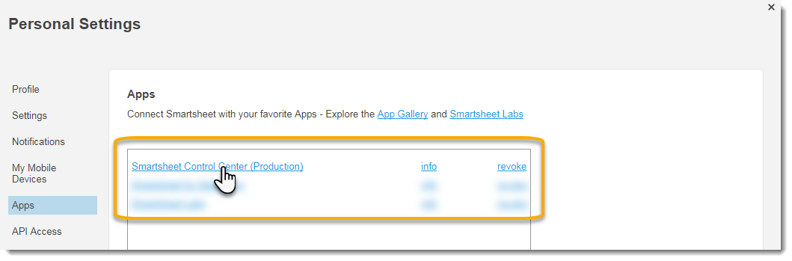

1. Click **Log in with Smartsheet** button in the next screen, and click **Allow** when prompted to “Allow Access?”

## Control Center

### The Home Page

#### Navigating to the Page

The home page is the first page you’ll land on when you log into Control Center. If you are in another part of Control Center, you can click the **Home Button** to return to that page.

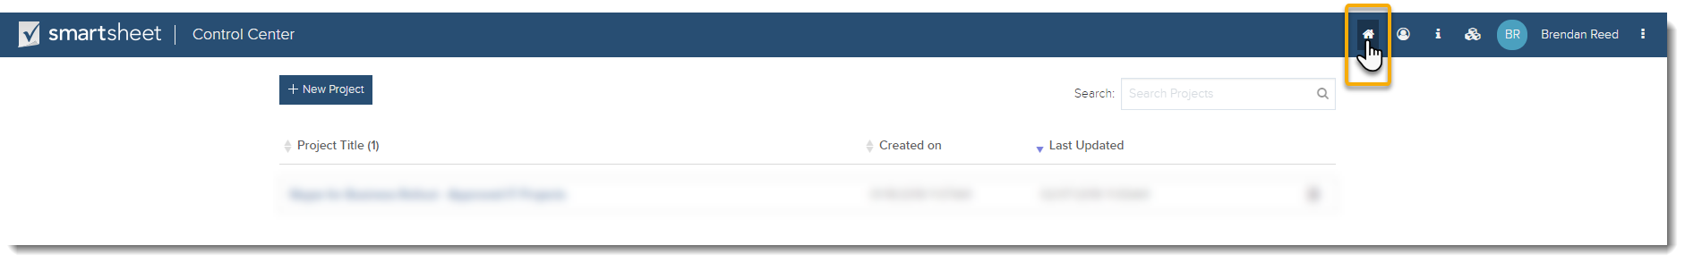

#### Page Contents

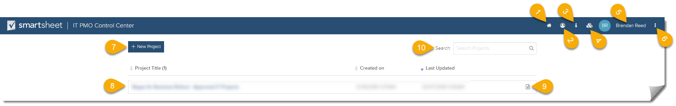

1. The **Home Button** will take you to the home page, the main Control Center page, where you can see your existing projects and deploy new projects.
2. The **PMO Button** is only available to licensed PMO users in Control Center and navigates to the section where you can access the Solution Builder and make Global Updates.
3. The **Information Button** displays useful information set by the PMO and is specific to your company’s Control Center environment.

***Tip****: Use this area to link out to key resources for your company’s program, or specific project components like sheets, reports, and dashboards.*

1. The **Configuration Button** displays the current Control Center configuration that is loaded.

***Tip****: Use unique configurations to restrict what project types or existing projects are available/viewable to specific users, groups, or departments.*

1. **User Information** is identified in the upper right hand corner.
2. The **User Menu** is where you can find the **Log out** button.
3. The **+ New Project** button is where you can start creating a new Control Center project.
4. The **Existing Projects** list displays all provisioned projects. Projects can be sorted by **Project Title**, **Created On** date, and **Last Updated** date.
5. The **Logs** button displays all actions and when they were taken on the project, similar to Smartsheet’s Activity Log.
6. The **Search** box lets you search through provisioned projects in Control Center.

### New Project page

#### Navigating to the Page

From the Home Page in Control Center, click **+ New Project** to get to the New Project page.

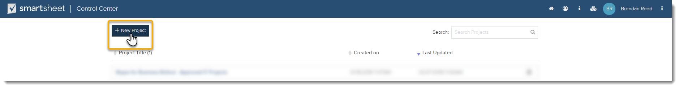

#### Page Contents

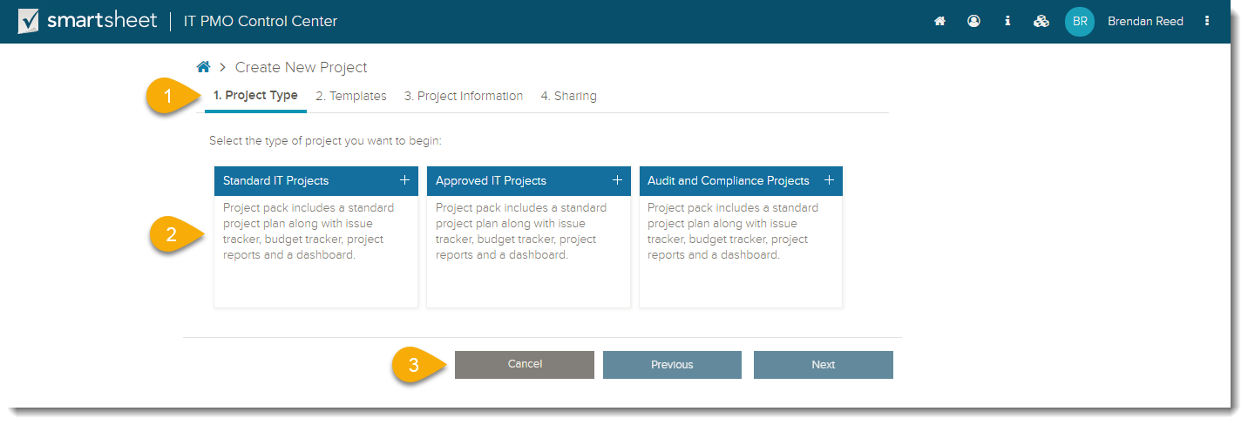

1. The **Step Indicator** shows the step you are at in the project provisioning process. This will be covered in more detail in the “Provisioning a Project” section.
2. The table on the new project pages shows all available project types for the user. **Project Types** are project templates with specific sheets, reports, and dashboards defined by the PMO. A **Project Type Description** can be found under each project type, and should detail when to use the specific project type and its contents .
3. The bottom buttons are **Cancel**, return to home screen, **Previous**, to go to the previous step, and **Next**, to go to the next step.

### The Project Update Page

#### Navigating to the Page

From the Home Page in Control Center, click on an existing project to go to the project update page.

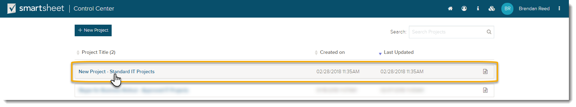

#### Page Contents

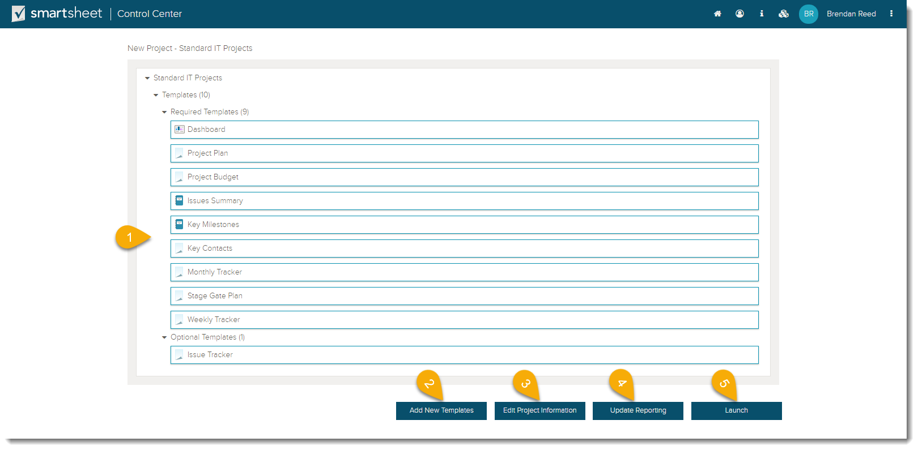

1. The **Project Components** table show all templates currently in the provisioned project, separated by required and optional templates.
2. The **Add New Templates** button will take you into the templates screen for the selected project, where you can adjust your selected optional templates.
3. The **Edit Project Information** button takes you into the project information screen where you can view and update the metadata for the selected project.
4. The **Update Reporting** button resyncs the reports in a provisioned project.

***Tip****: Use this button if you add or remove any optional templates to your project, or if your new project is not showing up in the aggregate reporting for your project portfolio dashboard.*

1. The **Launch** button takes you into Smartsheet and into the specific workspace or folder for the selected project.

## Provisioning a Project

### Project Kickoff (Intake)

**Project Kickoff** (Intake process) is tracked on a sheet that collects project initiation data. The sheet has unique fields used for identifying new project requests, projects that are in motion for approval, and provisioned projects; and each unique project has it’s on row.

1. New project requests are kicked off using **Webforms**. Webforms are completely customizable and are used to gather initial project request information.

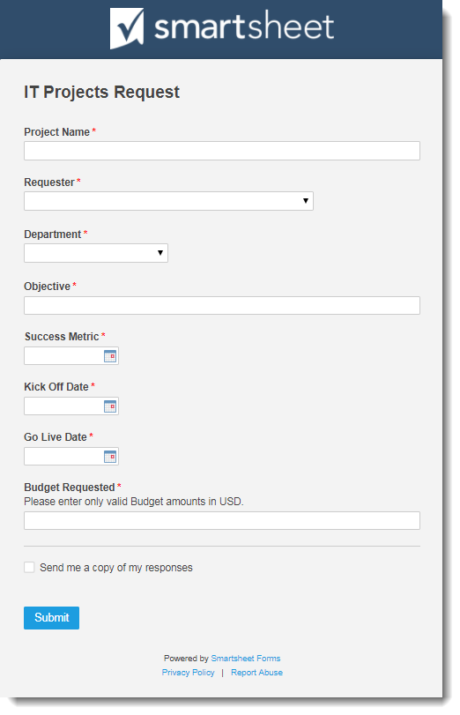

For more information about webforms, please review the [webform help article](https://help.smartsheet.com/articles/522221-using-web-forms).

1. New Webform submissions (new requests) are logged on the **Intake sheet** and stored there.

There are several key fields that should be included on an intake sheet. A **Project Approval Column** to indicate the state of approval for a project. A **Provision Column** that indicates if the project has been provisioned. A **Project Folder URL Column** that provides a direct link to the folder or workspace with all of the projects components if it’s provisioned. A **Selection Column** for the project name or descriptor for the specific Control Center project.

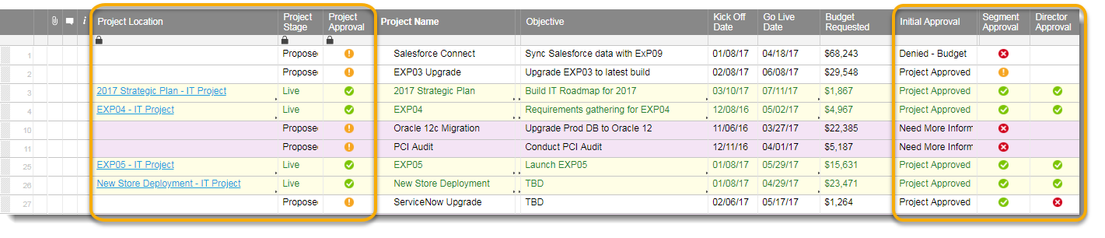

1. With **Actions and Alerts**, approval processes or requests for additional information can be triggered automatically.

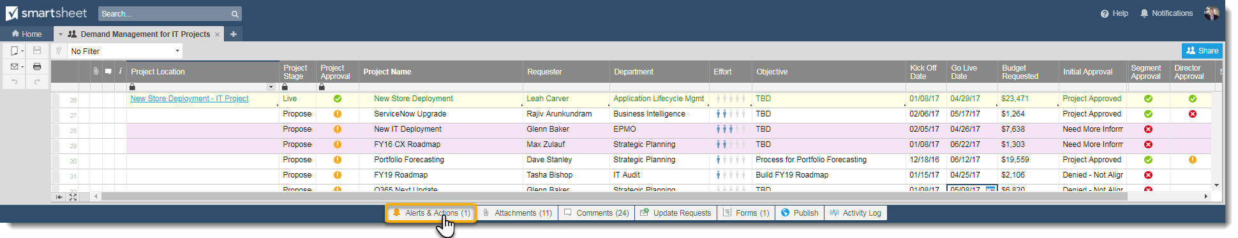

***Tip****: Use alerts and actions to eliminate manual work and set up automated data gathering and approval processes before the project is provisioned by Control Center. Learn more about* [*alerts and actions here*](https://help.smartsheet.com/articles/2476191-alerts-stay-on-track-with-automatic-notifications-and-reminders?_ga=2.112545606.378251021.1520269177-1174838062.1517507359)*.*

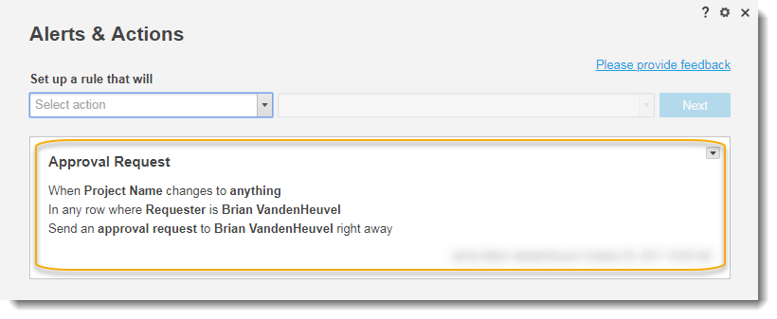

### Project Setup - 1. Project Type

1. [Login to Control Center](https://smartsheet.controlcenter.smartsheetapps.com) or navigate to the home page by click the **Home Button**.
2. Select **+ New Project**



1. Select the desired **Project Type**.

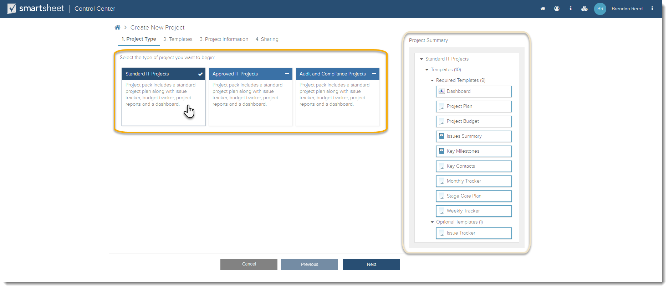

After selecting a Project Type, you can preview the required and option templates in the **Project Summary** section before proceeding to the next step.

1. Click **Next** to proceed to the next step, or **Previous** to return to the home screen.

### Project Setup - 2. Templates

Step **2. Templates** is the step where you define the optional templates to be included in your project. Required Templates, as the name implies, can not be excluded or changed in the project.

1. Select the **Optional Templates** to be included in the project, either from the optional templates picklist or the Project Summary.

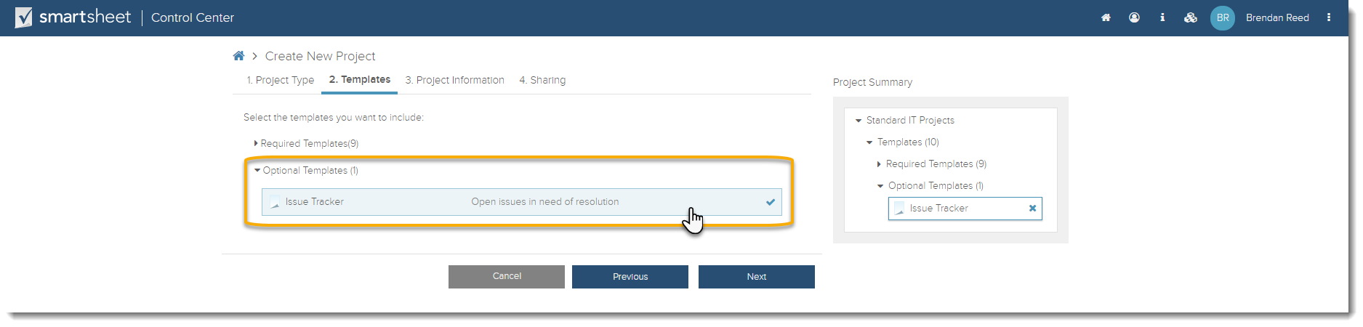

1. Click **Next** to proceed to **3. Project Information**, or **Previous** to return to step **1. Project Type** to change your selection.

### Project Setup - 3. Project Information

Step **3. Project Information** is the step where you define the specific Metadata for the project type that will be used in the project.

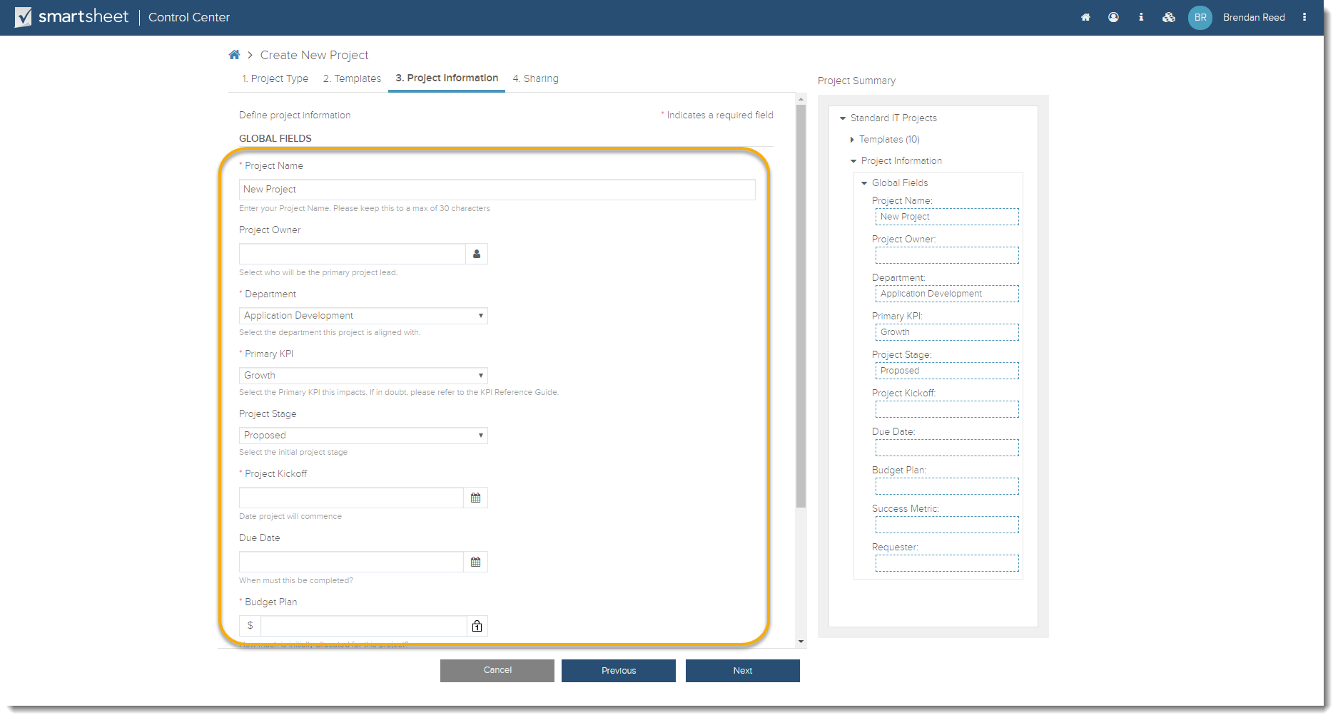

1. Fill in all **Required Metadata** for your project, and any optional Metadata that you’d like prepopulated.
2. Click **Next** to proceed to **4. Sharing**, or **Previous** to return to step **2. Project Type** to change your selection.

***Tip****: Connect your Salesforce instance to Control Center to automatically connect your pre-project data to the project information step.*

### Project Setup - 4. Sharing

Step **4. Sharing** is the step where you define the user access permissions, on the project level and sheet level, and the restrictions that these users have. Learn more about [**Smartsheet Permission Levels**](https://help.smartsheet.com/articles/1155182-sharing-permission-levels).

1. The **Basic** sharing section is where you assign project level Admins, Editors that can or can’t share, and viewers. Each permission level will restrict what a assigned user can do. For more information on Smartsheet User Permissions, check out this article.

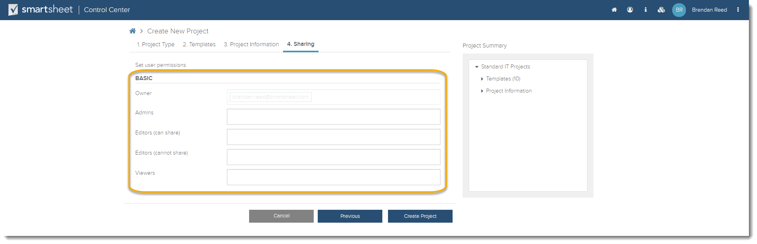

1. The **Advanced** sharing section allows you to grant certain user permissions on the sheet level, instead of the project level.

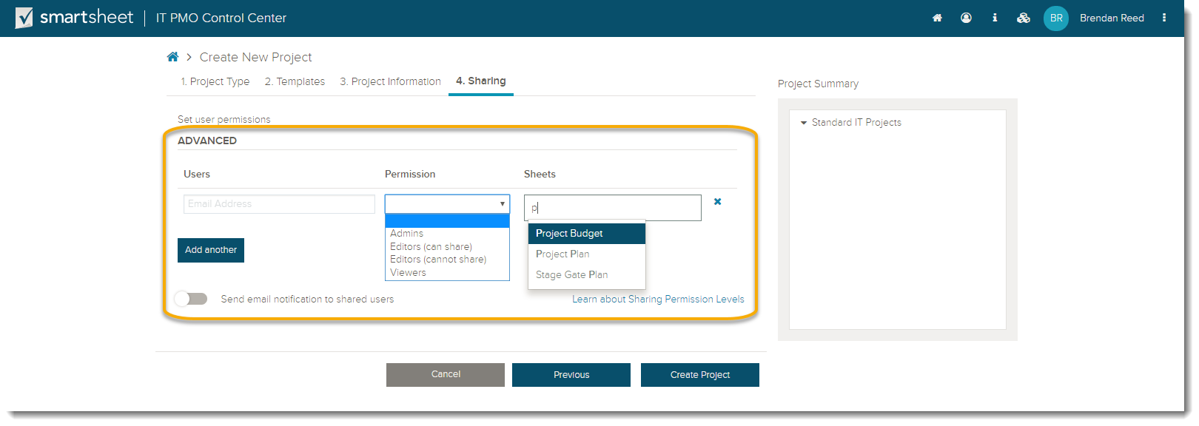

***Tip****: Connect your Salesforce instance to Control Center to automatically connect your pre-project data to the project information step.*

### Project Provisioning

Before provisioning the project, confirm that all inputs are correct and that you have defined the necessary user permissions. Once a project is created it can’t be undone.

1. Click **Create Project** on step **4. Sharing** to provision the project. It will take Control Center a few seconds to create the project contents, content the sheets to the reports, send out the sharing permissions, and publish.
2. Once the project has been provisioned, you’ll see the below screen with a link to the workspace in Smartsheet. You can also click **Ok** and then **Launch** to access the provisioned project.

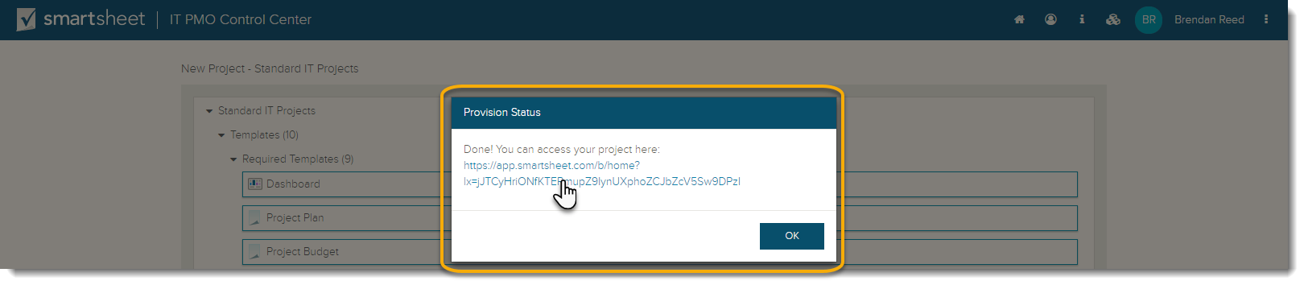

***Tip****: If you’d like to make any updates to the project, you can do so from this screen by clicking* ***Ok*** *and selecting the options at the bottom of the page. This will be covered in more detail in the section about project updates.*

### Project and Portfolio Reports and Dashboards

Project reports and dashboards can be found in the specific project folder in Smartsheet. These items can be connected to a portfolio level dashboard in order to see status across all projects.

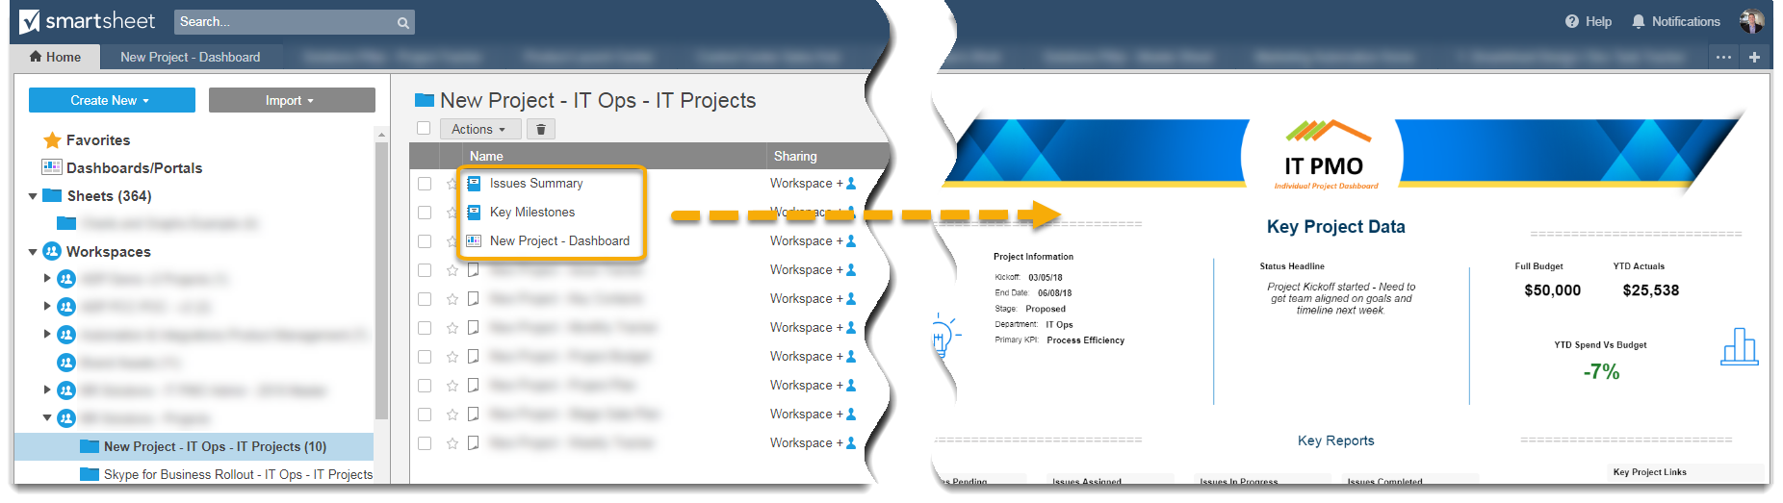

### Working with Provisioned Projects

Project reports and dashboards can be found in the specific project folder in Smartsheet. These items can be connected to a portfolio level dashboard in order to see status across all projects.

## Updating a Project

There are several project components that you can update after they’ve been provisioned. This section will detail how you can update project templates, metadata, options, and reports. All options

### Updating Project Templates

1. Go to the **Project Update** page on a specified project.
2. Click on **Add New Templates**

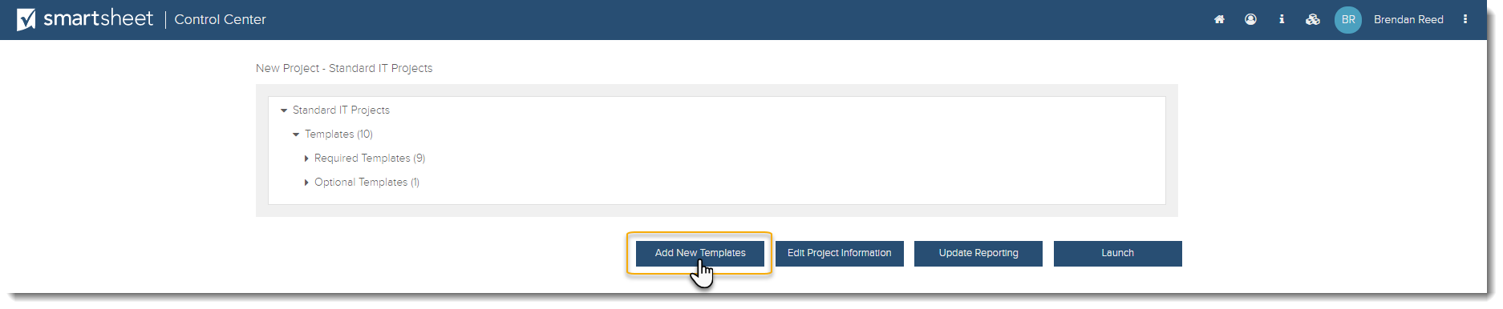

1. If there are any available **Optional Templates** that aren’t added to the provisioned project already, then you can select them here. Adding the template will push it to the selected sheet, and all other provisioned projects of the same type.

### Updating Project Metadata

1. Go to the **Project Update** page on a specified project.
2. Click on **Edit Project Information**.

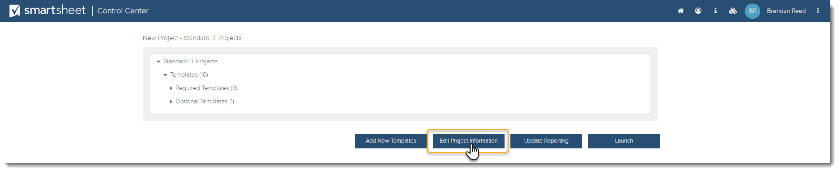

1. This will take you to the project information page, where you can change the core Metadata on the project.
2. Click **Update** to save the changes made to the project.

## PMO

If you are a PMO for Control Center and you are looking for more detailed information, checkout our [PMO help articles in our Help Center](https://help.smartsheet.com/articles/2476701-smartsheet-control-center-frequently-asked-questions).

PMO Documentation coming soon.